Data Structures

Lecture No. 45

Reading Material
Data Structures and Algorithm Analysis in C++ Chapter. 7 7.6, 7.7

Summary
- Divide and Conquer
- Mergesort
- mergeArrays
- Mergesort and Linked Lists
- Mergesort Analysis
- Quicksort
- Course Overview

Divide and Conquer
In the previous lecture, we had started discussing three new sorting algorithms; merge sort, quick sort and heap sort. All of these three algorithms take time proportional to nlog₂n. Our elementary three sorting algorithms were taking n² time; therefore, these new algorithms with nlog₂n time are faster. In search operation, we were trying to reduce the time from n to log₂n.

Let’s discuss these sorting algorithms; merge sort, quick sort and heap sort in detail.
We had started our discussion from divide and conquer rule where we also saw an example. Instead of sorting a whole array, we will divide it in two parts, each part is sorted separately and then they are merged into a single array.

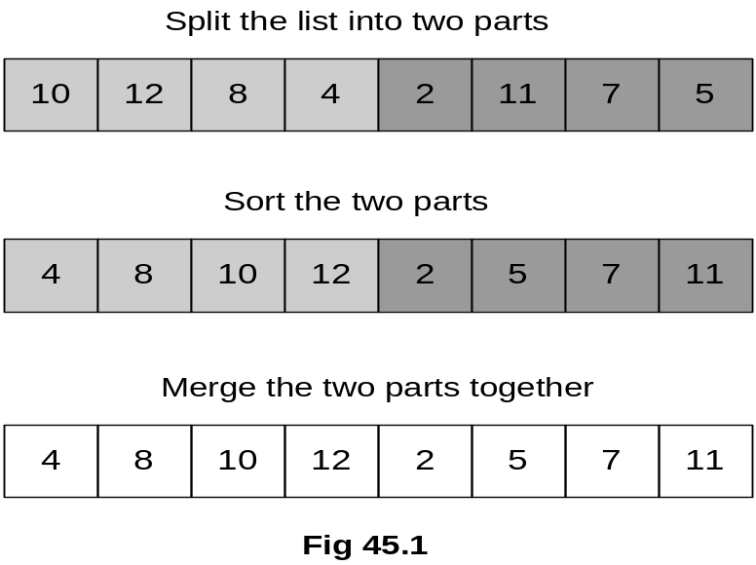

Let’ see few analysis to confirm the usefulness of the divide and conquer technique.
- To sort the halves approximate time is (n/2)2+(n/2)2

- To merge the two halves approximate time is n
- So, for n=100, divide and conquer takes approximately:
= (100/2)2 + (100/2)2 + 100
= 2500 + 2500 + 100
= 5100 (n2 = 10,000)

We know that elementary three sorting algorithms were taking approximately n² time. Suppose we are using insertion sort of those elementary algorithms. We divide the list into two halves then the time will be approximately (n/2)2+(n/2)2. The time required for merging operation is approximately n. This operation contains a simple loop that goes to n.
Suppose that n is 100. Considering if we apply insertion sort algorithm on it then the time taken will be approximately (100)² = 10000. Now, if we apply divide and conquer technique on it. Then for first half approximate time will be (100/2)². Similarly for second half it will be (100/2)². The merging approximate time will be 100. So the whole operation of sorting using this divide and conquer technique in insertion sort will take around (100/2)² + (100/2)²+100 = 5100. Clearly the time spent (5100) after applying divide and conquer mechanism is significantly lesser than the previous time (10000). It is reduced approximately to half of the previous time. This example shows the usefulness of divide and conquer technique.

By looking at the benefit after dividing the list into two halves, some further questions arise:

- Why not divide the halves in half?
- The quarters in half?
- And so on . . .
- When should we stop?
At n = 1

So we stop subdividing the list when we reach to the single element level. This divide and conquer strategy is not a thing, we have already prepared binary search tree on the same lines. One side of the tree contains the greater elements than the root and other part contains the smaller elements. Especially, when performing binary search in an array, we had started our search from mid of it. Subdivided the array and kept on comparing and dividing the array until we got success or failure. The subdivision process may prolong to individual element of the array.

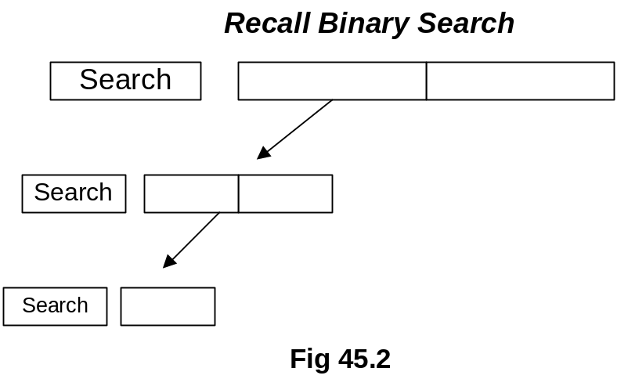
Hence, we used to perform binary search on the same lines of divide and conquer strategy. Remember, we applied binary search on sorted array. From this one can realize that sorting facilitates in searching operations.

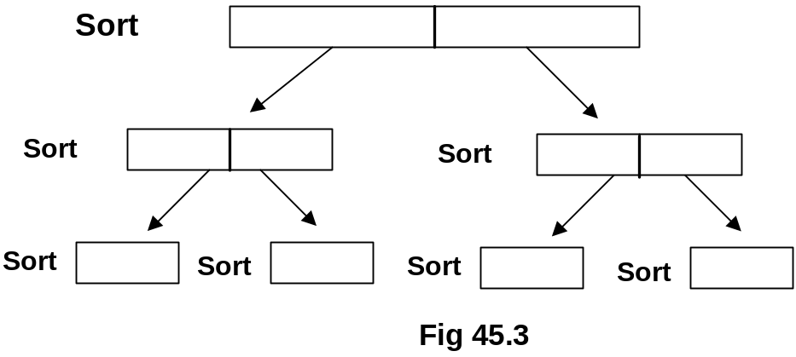

In figure 45.3, in order to sort the list, we have divided the list in the two parts and each part is subdivided into further subparts. At end each part is consisting of either single element or maximum two elements. If we have two numbers to sort, we can compare them (or sort them) with single if statement. After sorting individual subparts, we start merging them in the upward direction as shown in the figure Fig 45.4.

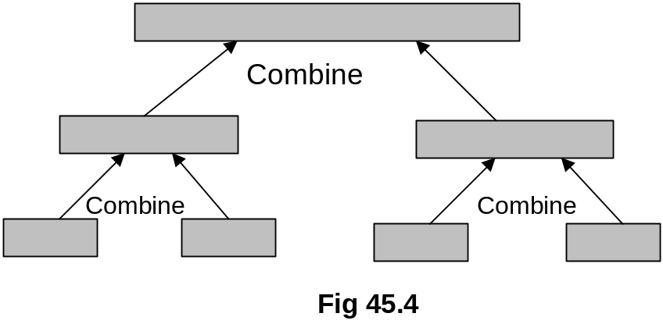
In Fig 45.4, we have four sorted smaller parts. We combine them to become two sorted parts and two sorted parts are further combined or merged to become one sorted list.

Mergesort
- Mergesort is a divide and conquer algorithm that does exactly that.
- It splits the list in half
- Mergesorts the two halves
- Then merges the two sorted halves together
- Mergesort can be implemented recursively

Let’s see the mergsort algorithm, how does that work.

- The mergesort algorithm involves three steps:
  - If the number of items to sort is 0 or 1, return
  - Recursively sort the first and second halves separately
  - Merge the two sorted halves into a sorted group

If the data is consisting of 0 or 1 element then there is nothing required to be done further. If the number of elements is greater than 1 then apply divide and conquer strategy in order to sort them. Divide the list into two halves and sort them separately using recursion. After the halves (subparts) have been sorted, merge them together to get a list of sorted elements.

We will discuss recursive sorting in a moment, before that let’s see the merging operation using pictures. We have two sorted array and another empty array whose size is equal to the sum of sizes of two sorted arrays.

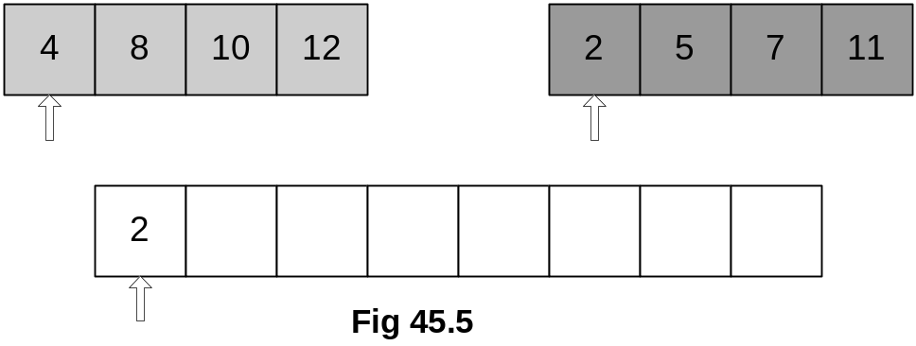

You can see from Fig 45.5, array 1 on the top left is containing 4 elements, top right is also containing 4 elements and both of them are sorted internally. Third array is containing 4+4 = 8 elements.
Initially, very first elements (present at the starting index 0 of array) of both the arrays are compared and the smaller of them is placed in the initial position of the third array. You can see from Fig 45.5 that elements 4 and 2 are compared pointed to by the indexes (actually arrays current indexes). The smaller of them is 2, therefore, it is placed in the initial position in the third array. A pointer (the current index of array) is also shown for third array that will move forward as the array is filled in. The smaller number was from right array, therefore, its pointer is moved forward one position as shown in Fig 45.6.

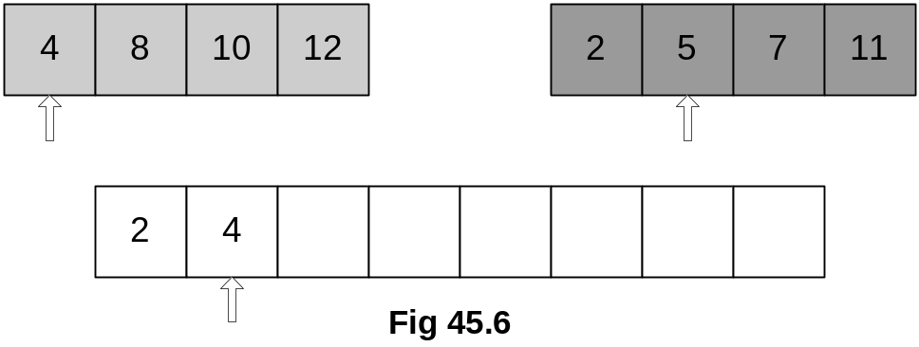

This time the numbers at current positions in both the arrays are compared. As 4 is smaller of the two numbers, therefore, it is put in the third array and third array’s pointer is moved one position forward. Also because this time, the number has been chosen from left array, therefore, its pointer is also moved forward. The updated figure is shown in Fig 45.7.

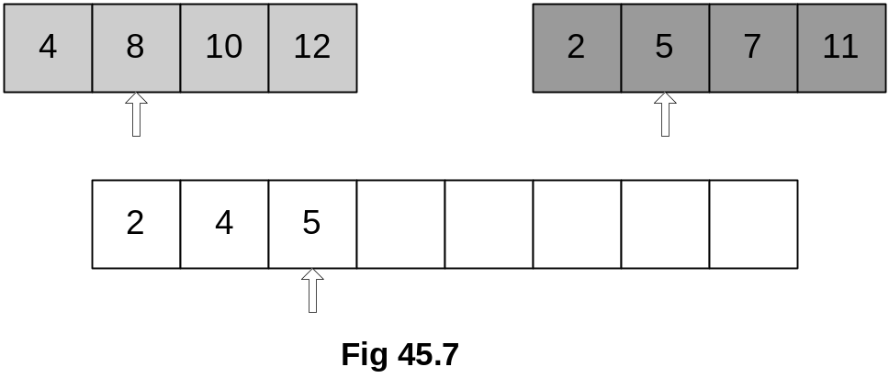

Next, numbers 8 and 5 are compared. As 5 is smaller of the two, it is put in the third array. The changed positions of pointers and the next comparison are shown in Fig 45.8.

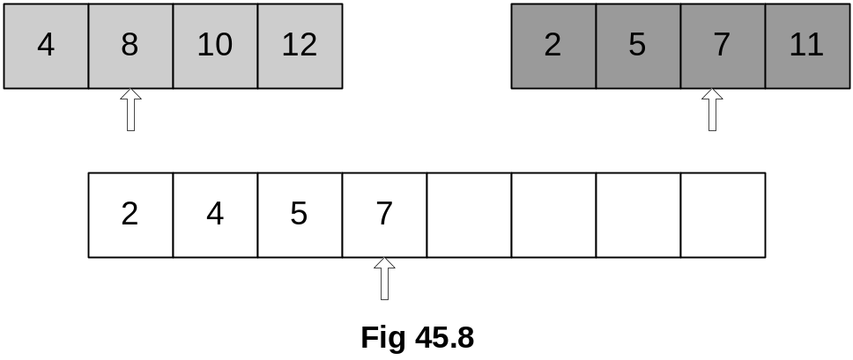
Fig 45.9 has showed the situation after next comparison done in the similar manner.

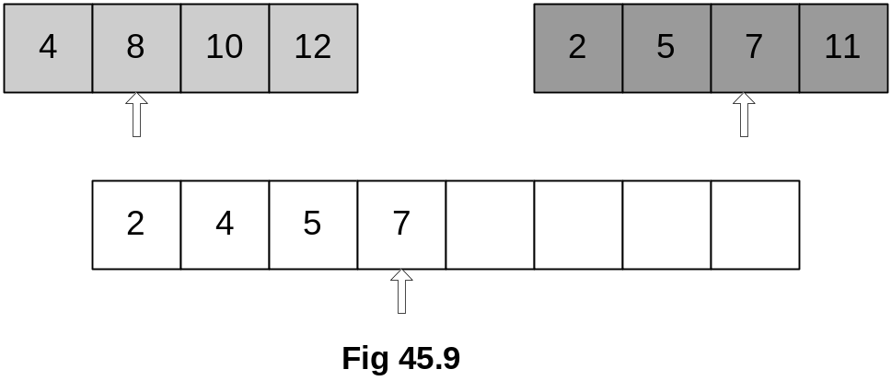

By now, you must have understood how the merging operation works. Remember, we do merging when we have two parts sorted already.
Consider this operation in terms of time and complexity. It is performed using a simple loop that manipulates three arrays. An index is used for first array, which starts from the initial position to the size of the array. Similar an index is used for second array, which starts from the initial position and ends at the end of the array. A third index is used for third array that sizes to the sum of the maximum values of both previous indexes. This is simple single loop operation, which is not complex.

Now, let’s see sorting using recursion now pictorially.

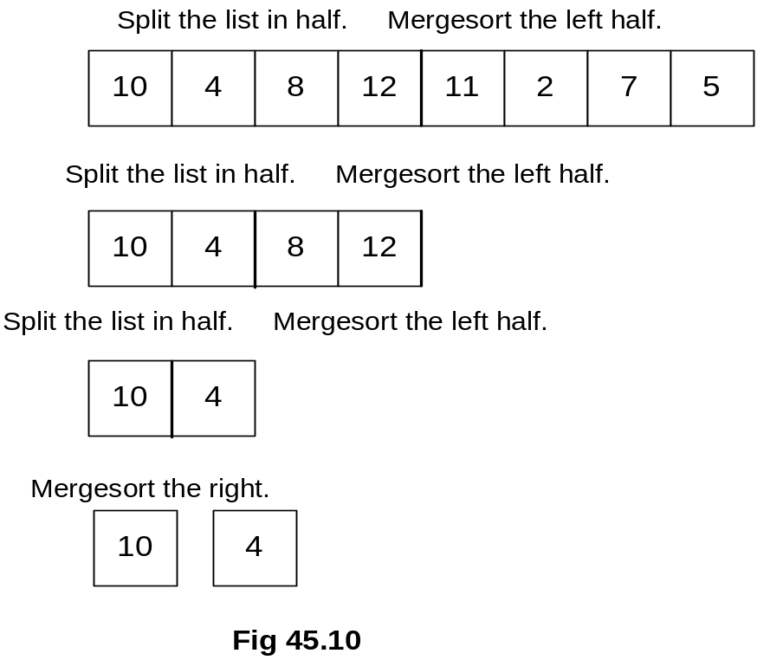

At the top of Fig 45.10 is an array, which is not sorted. In order to sort it using recursive mechanism, we divide the array into two parts logically. Only logical partitions of the array are required bases on size and index of the arrays. The left half of the array containing 10,4,8 and 12 is processed further for sorting. So actually, while calling the mergesort algorithm recursively, only that particular half of the array is a passed as an argument. This is spitted further into two parts; 10, 4 and 8, 12. 10, 4 half is processed further by calling the mergesort recursively and we get both numbers 10 and 4 as separate halves. Now these halves are numbers and they cannot be subdivided therefore recursive call to mergesort will stop here. These numbers (new halves) 10 and 4 are sorted individually, so they are merged. When they are merged, they become as 4,10 as shown in Fig 45.11.

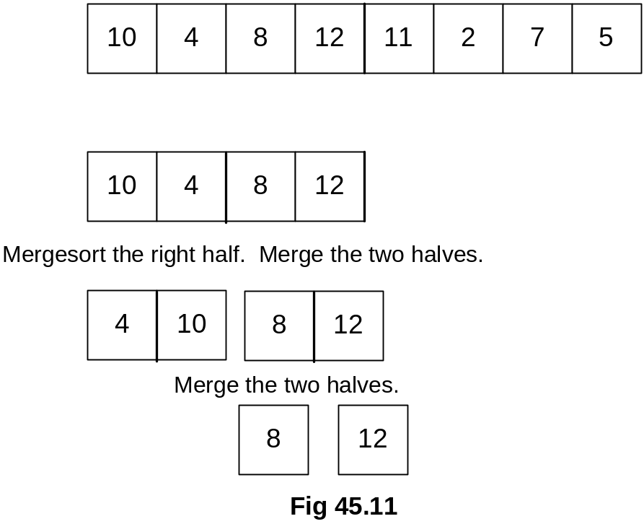

The recursive call to mergesort has done its work for left half that consisted of 10 and 4. Now, we apply the same technique (the recursive calls to mergesort) to the right half that was consisting of 8 and 12. 8 and 12 are spitted into separate numbers as indicated in Fig 45.11. Further division of them is not possible, therefore, they are merged as shown in Fig 45.12.

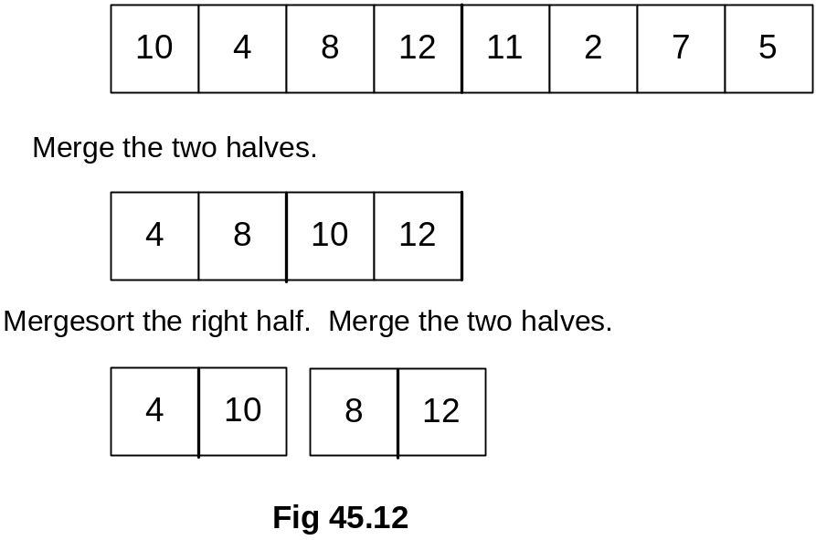

At this point in time, we have two parts one is containing elements as 4, 10 and other as 8, 12. These two parts are merged. The merged half is shown in Fig 45.12. Note that it is completely sorted as 4,8,10 and 12. This completes the operation on the left half of the array. We do similar process with the right half now, which is consisting of 11, 2, 7 and 5.

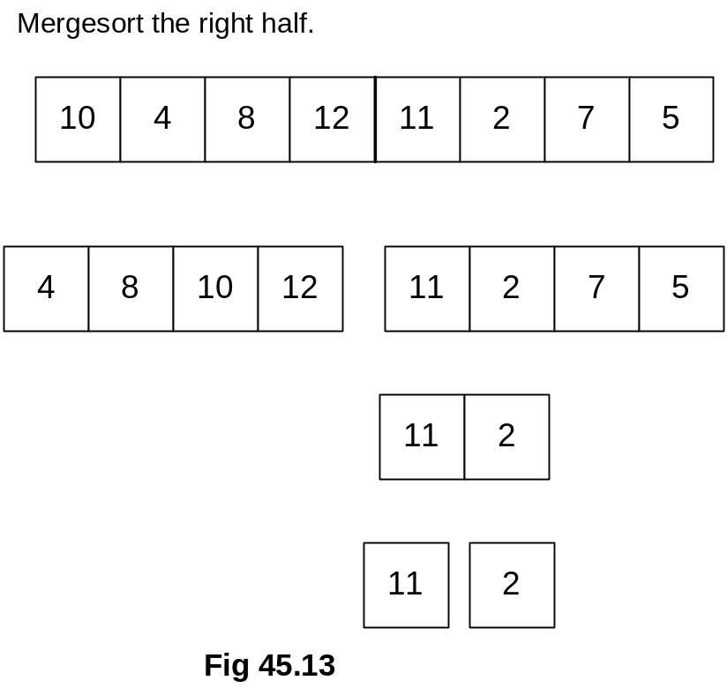

Similarly, left half of it 11,2 is processed recursively. It is divided into two halves and we have two parts as two individual numbers. The recursive call for this part stops here and the merging process starts. When the parts 11 and 2 are merged, they become one sorted part as shown in Fig 45.14.

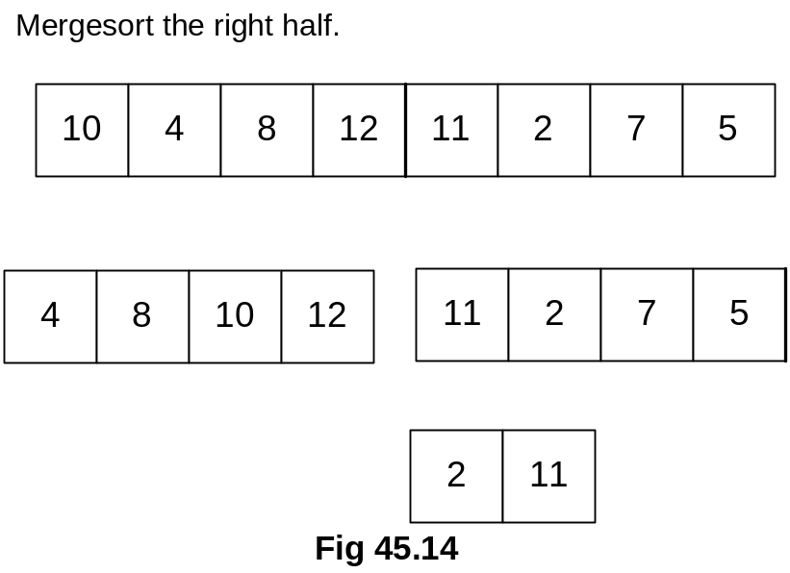

Now the same procedure is applied on right half consisting of 7 and 5. By applying recursive mechanism, it is further subdivided into two individual number parts.

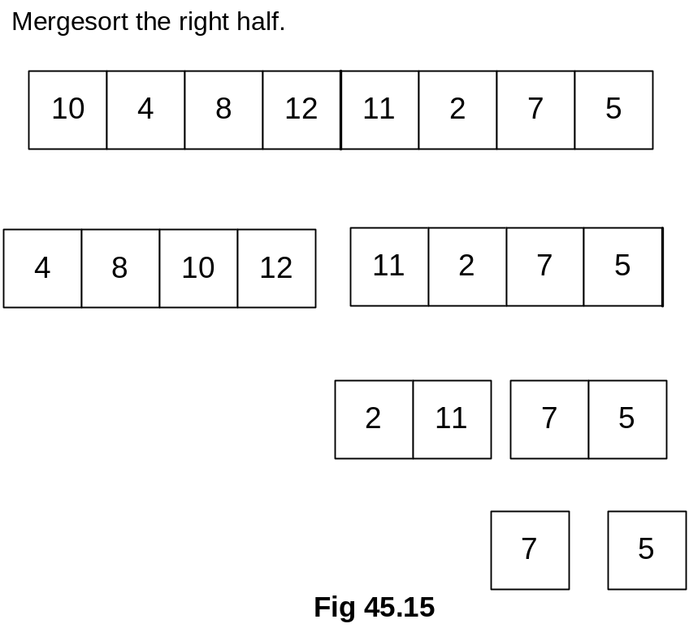

The merging operation starts, the resultant is shown in the Fig 45.16. After merging, the new part has become 5,7.

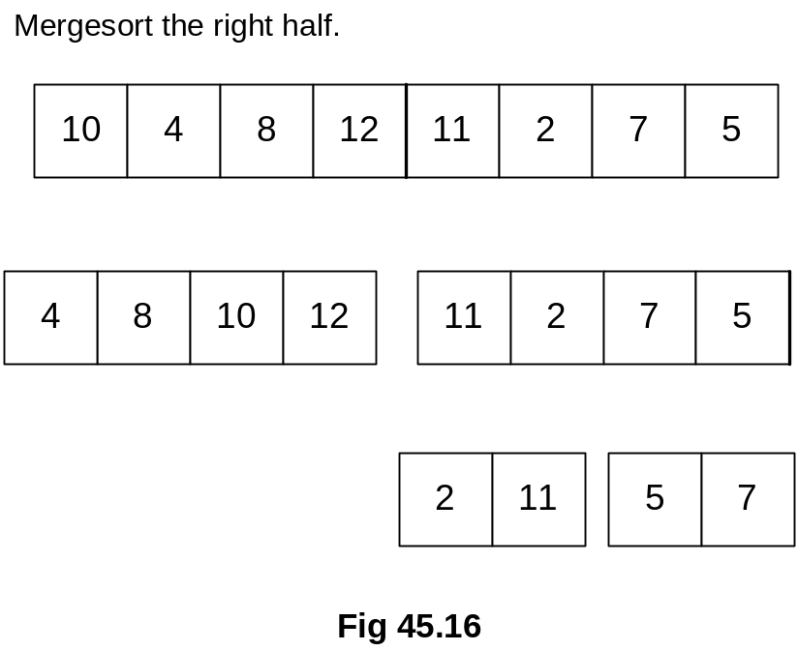

When 5,7 merged part is further merged with already merged part 2,11. The new half becomes as 2,5,7,and 11 as shown in Fig 45.17.

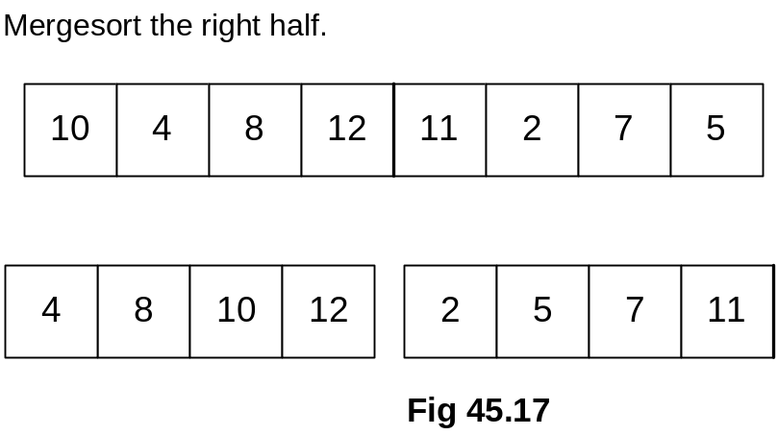

Now, we can merge the two biggest halves to get the array in sorted order. After merging, the resulted sorted array is shown in Fig 45.18.

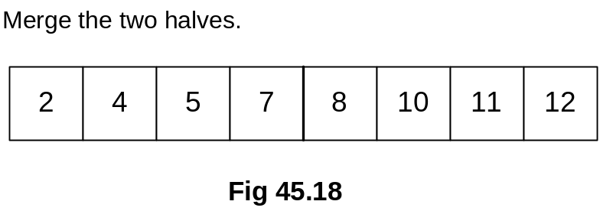

Let’s see the C++ code for this sorting algorithm. We are not going to write a class of it but at the moment, we are only writing it as a procedure. We can use it standalone or later on, we can also change it to make it a class member.

void mergeSort(float array[], int size)
{
int * tmpArrayPtr = new int[size];

if (tmpArrayPtr != NULL)
mergeSortRec(array, size, tmpArrayPtr);
else
{
cout << “Not enough memory to sort list.\n”);
return;
}

delete [] tmpArrayPtr;
}

void mergeSortRec(int array[], int size, int tmp[])
{
int i;
int mid = size/2;

if (size > 1)
{
mergeSortRec(array, mid, tmp);
mergeSortRec(array+mid, size-mid, tmp);

mergeArrays(array, mid, array+mid, size-mid, tmp);
for (i = 0; i < size; i++)
array[i] = tmp[i];
}
}

The name of the procedure is mergeSort, it is accepting first argument as an array of floats and as second argument as an int. The second parameter is containing the size of the array. Inside the function, we have created a temporary array tmpArrayPtr dynamically of the same size as the size passed in the second argument. This array will be used for merging operation. In the next if statement if (tmpArrayPtr != NULL), allocation for dynamic array is being checked, if it is allocated then another function mergeSortRec is called. Its first argument is float’s array array , second argument is int size, and third argument is tmpArrayPtr.
In mergeSortRec, we divided the size of the array by 2 to get the mid of the array. If the size of the array is greater than 1 then inside the if-statement, mergeSortRec is being called recursively two times. In first recursive call, mergeSortRec(array, mid, tmp); we provided the array from index 0 to mid. For second recursive call, mergeSortRec(array+mid, size-mid, tmp);we provided the array starting from one position ahead of mid position to the end of the array, however, the size of the passed array is size-mid. The first recursive call will keep on executing by further subdividing the left part of the half every time until the size of the array reduces to 1. Similarly, the second recursive call keeps on working on the right half of the array until the size of the array reduces to 1. After both of these recursive calls will be completed then the merging operation is performed by calling mergeArrays. At end, inside the for loop, the sorted data is copied from tmp array to the actual array array.

mergeArrays
Let’s see the merging of two array while using their indexes as i and j.

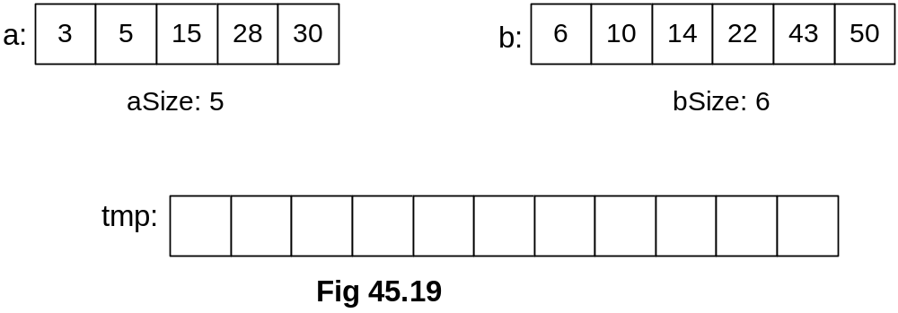

We are doing the same operation of merging of arrays but with little more detail here. One the left is an array a consisting of 2,5,15,28 and 30 and on the right is another array b consisting of 6,10,14,22,43 and 50. The size of array a is 6 while b’s size is 6. We create a temporary array named tmp, whose size is 11. We have used indexes i, j and k for arrays a, b and tmp respectively and each one of them has been initialized with 0.
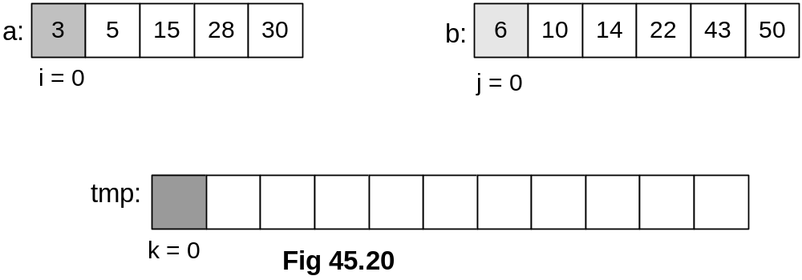

We compare the initial elements 3 and 6 of the arrays a and b. As 3 is smaller than 6, therefore, it is put in the temporary array tmp’s starting location where k=0.

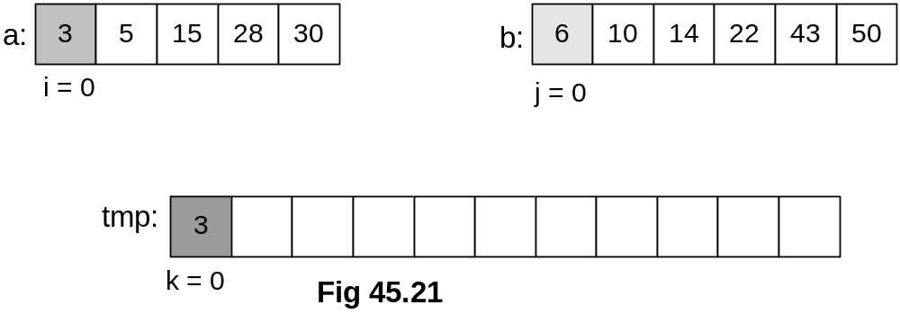

i is incremented and now elements 5 and 6 are compared. 5 being smaller of these take the place in the tmp array as shown in Fig 45.22.

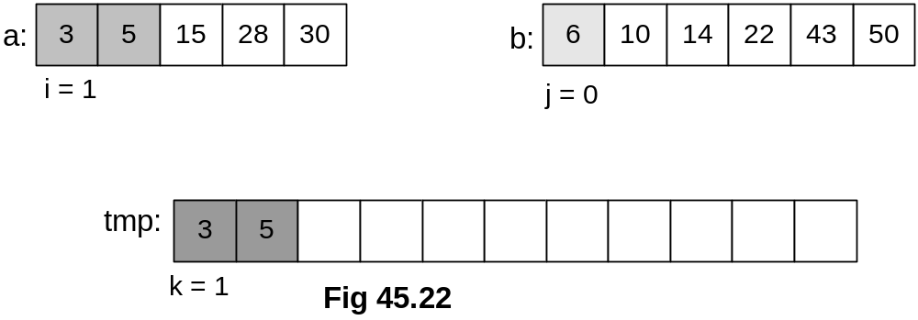

i is incremented again and it reaches the element 15. Now, elements 15 and 6 are compared. Obviously 6 is smaller than 15, therefore, 6 will take the place in the tmp array as shown in Fig 45.23.
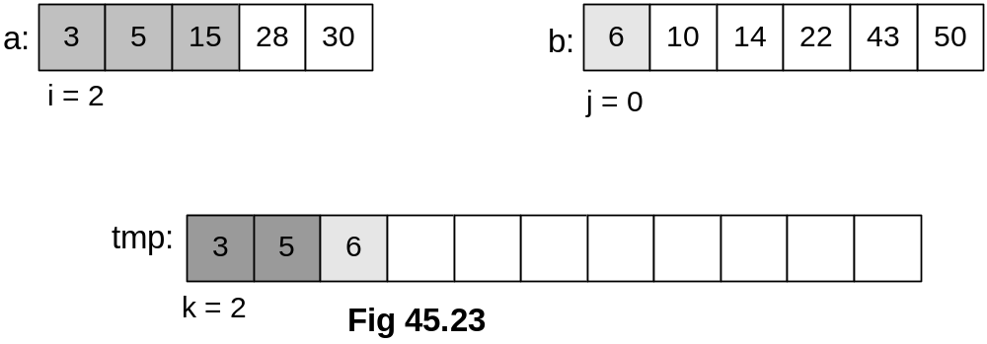

Because this time the element was taken from right array with index j, therefore, this time index j will be incremented. Keep an eye on the index k that is increasing after every iteration. So this time, the comparison is made between 15 and 10. 10 being smaller will take the place in tmp array as shown in Fig 45.24.
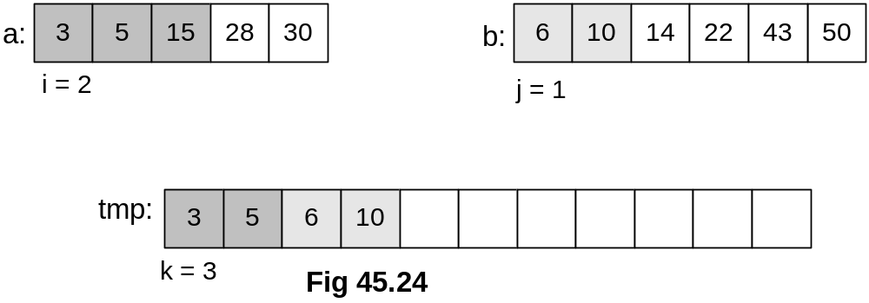

Again, j will be incremented because last element was chosen from this array. Elements 15 and 14 are compared. Because 14 smaller, so it is moved to tmp array in the next position.

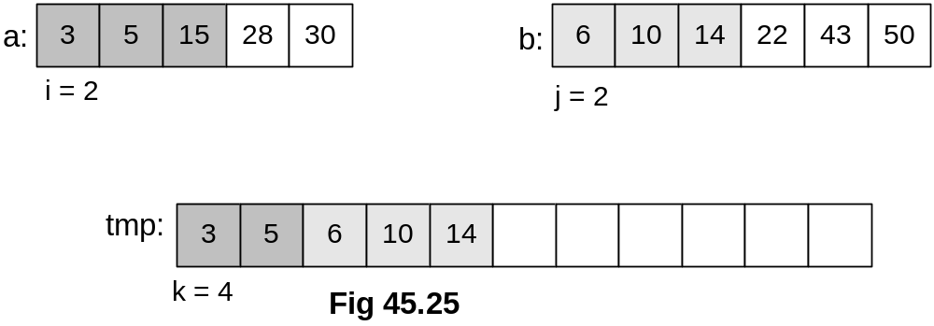

With these movements, the value of k is increasing after each iteration. Next, 22 is compared with 15, 15 being smaller of two is put into the tmp array as shown in Fig 45.26.

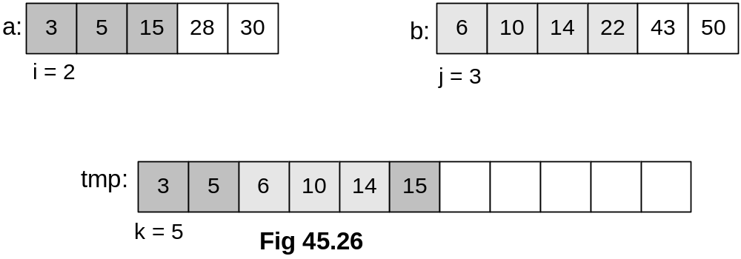

By now , you must have understood how this is working, let’s see the next iterations pictures below:

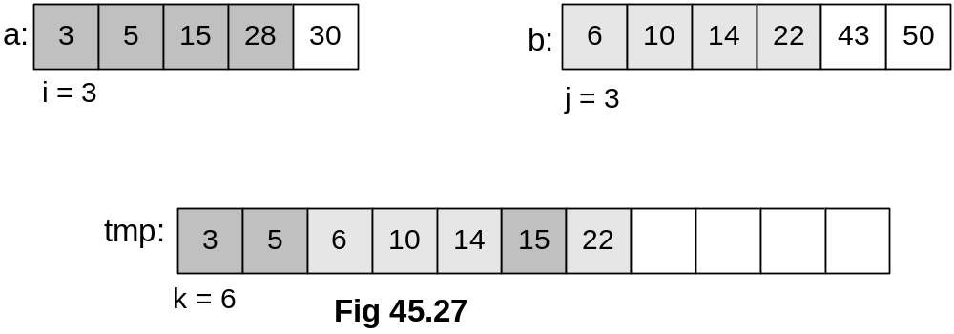

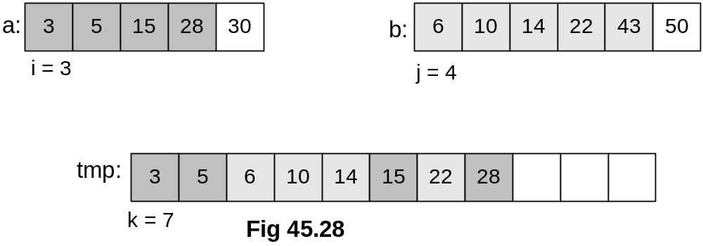

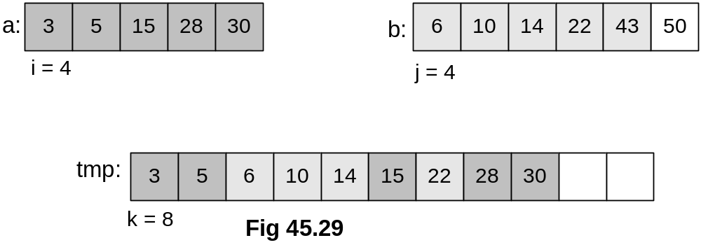
Note that array a is all used up now, so the comparison operation will end here. All the remaining elements of array b are incorporated in tmp array straightaway as shown in Fig 45.30. Hence, we have the resultant merged array tmp as shown in the figure.

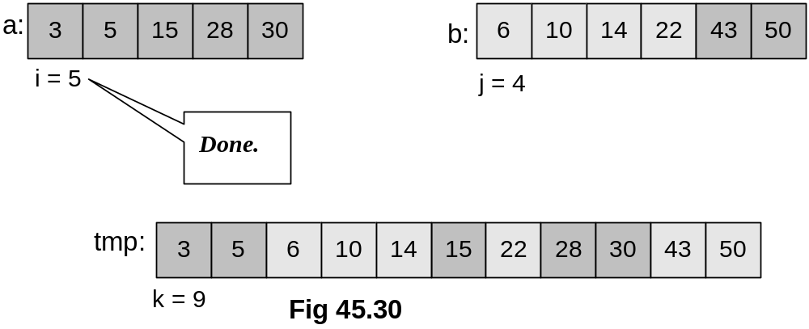

Mergesort and Linked Lists
Merge sort works with arrays as well as linked lists. Now we see, how a linked list is sorted. Suppose we have a singly linked list as shown in figure Fig 45.31. We can divide the list into two halves as we are aware of the size of the linked list. Each half is processed recursively for sorting. Both of the sorted resultant halves are merged together.

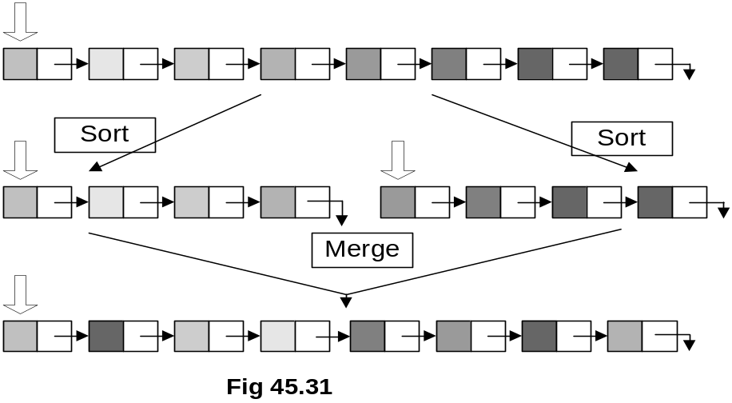
Mergesort Analysis
As you have seen, we used an additional temporary array while performing the merging operation. At the end of the merging operation, elements are copied from temporary array to the original array. The merge sort algorithm is not an inplace sorting algorithm because it requires an additional temporary array of the same size as the size of the array under process for sorting. This algorithm is still a good sorting algorithm, we see this fact from its analysis.

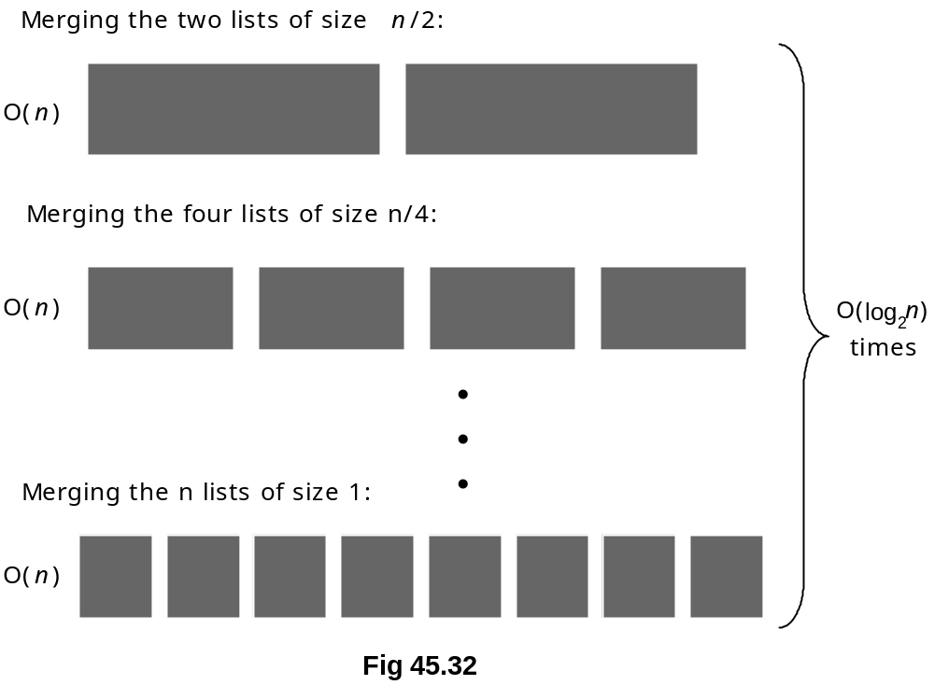

- Mergesort is O(n log₂ n)
- Space?
- The other sorts we have looked at (insertion, selection) are in-place (only require a constant amount of extra space)
- Mergesort requires O(n) extra space for merging

As shown in Fig 45.32, the array has been divided into two halves. We know that merging operation time is proportional to n, as it is done in a single loop regardless of the number of equal parts of the original array. We also know that this dividing the array into halves is similar mechanism as we do in a binary tree and a complete or perfect balance tree has log₂n number of levels. Because of these two factors, the merge sort algorithm is called nlog₂n algorithm. Now, let’s discuss about quick sort algorithm, which is not only an nlog₂n algorithm but also an inplace algorithm. As you might have guessed, we don’t need an additional array while using this algorithm.
Quicksort
- Quicksort is another divide and conquer algorithm.
- Quicksort is based on the idea of partitioning (splitting) the list around a pivot or split value.

Quicksort is also a divide and conquer algorithm. We see pictorially, how the quick sort algorithm works. Suppose we have an array as shown in the figure Fig 45.33.

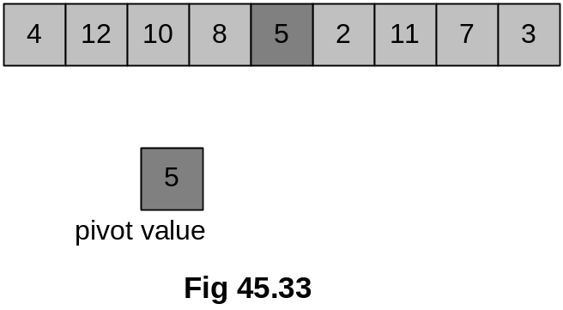

We select an element from the array and call it the pivot. In this array, the pivot is the middle element 5 of the array. Now, we swap this with the last element 3 of the array. The updated figure of the array is shown in Fig 45.34.

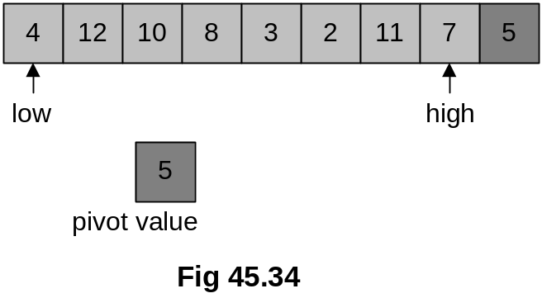

As shown in Fig 45.34, we used two indexes low and high. The index low is started from 0th position of the array and goes towards right until n-1th position. Inside this loop, an element that is bigger than the pivot is searched. The low index is incremented further as 4 is less than 5.

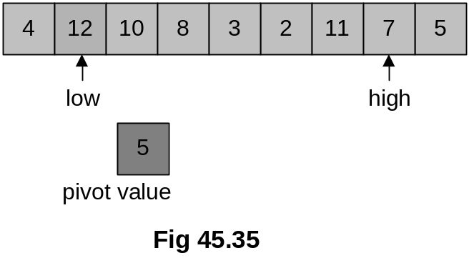
low is pointing to element 12 and it is stopped here as 12 is greater than 5. Now, we start from the other end, the high index is moved towards left from n-1th position to 0. While coming from right to left, we search such an element that is smaller than 5. Elements 7 and 11 towards left are greater than 5, therefore, the high pointer is advanced further towards left. high index is stopped at the next position as next element 2 is smaller than 5. Following figure Fig 45.36 depicts the latest situation.

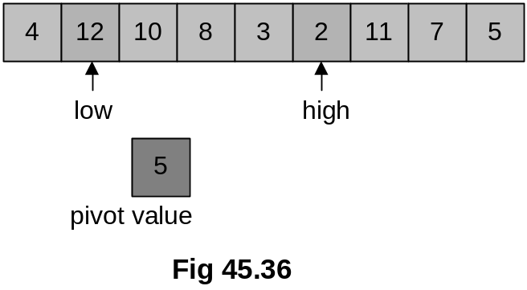

Both of the indexes have been stopped, low is stopped at a number 12 that is greater than the pivot and high is stopped at number 2 that is smaller than the pivot. In the next step, we swap both of these elements as shown in Fig 45.37.

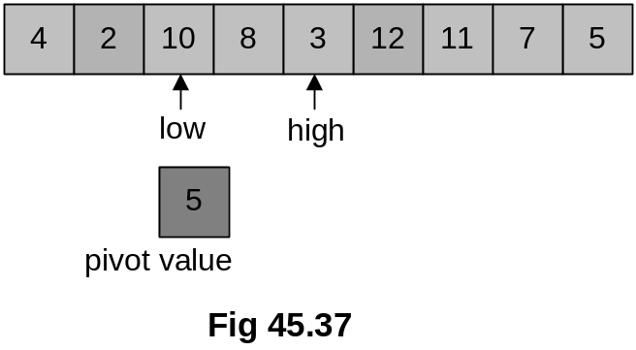

Note that our pivot element 5 is still there at its original position. We again go to index low and start moving towards right, trying to find a number that is greater than the pivot element 5. It immediately finds the next number 10 greater than 5. Similarly, the high is moved towards left in search to find an element smaller than the pivot element 5. The very next element 3 is smaller than 5, therefore, the high index stops here. These elements 10 and 3 are swapped, the latest situation is shown in Fig 45.38.

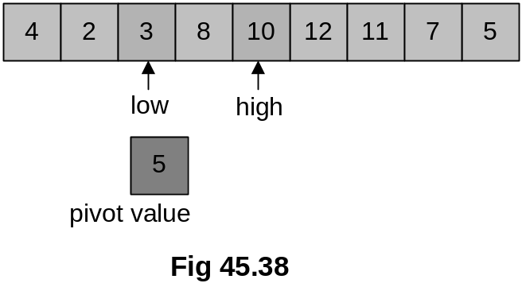

Now, in the next iteration both low and high indexes cross each other. When the high pointer crosses the low pointer, we stop it moving further as shown in Fig 45.39 and swap the element at the crossing position (which is 8) with the pivot number as shown in Fig 45.40.

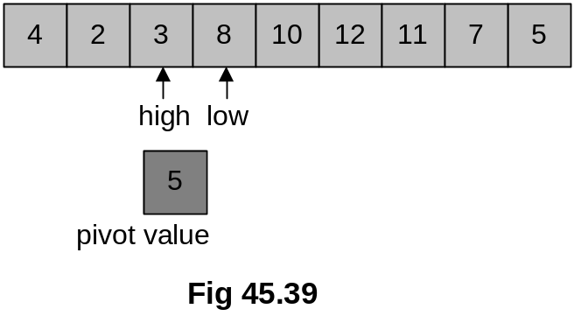

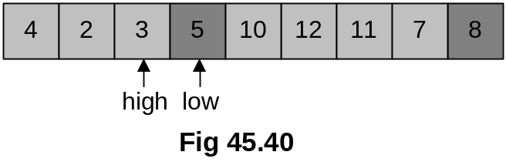

This array is not sorted yet but element 5 has found its destination. The numbers on the left of 5 should be smaller than 5 and on right should be greater than it and we can see in Fig 45.40 that this actually is the case here. Notice that smaller numbers are on left and greater numbers are on right of 5 but they are not sorted internally.
Next, we recursively quick sort the left and right parts to get the whole array sorted.

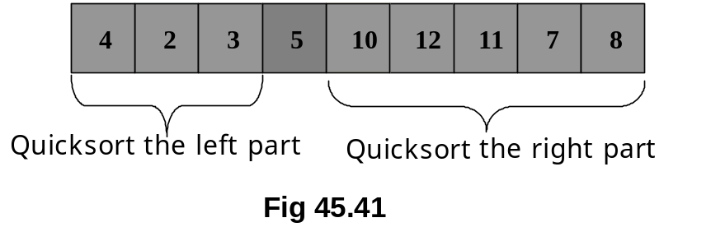

Now, we see the C++ code of quick sort.

void quickSort(int array[], int size)
{
int index;

if (size > 1)
{
index = partition(array, size);
quickSort(array, index);
quickSort(array+index+1, size - index-1);
}
}

int partition(int array[], int size)
{
int k;
int mid = size/2;
int index = 0;

swap(array, array+mid);
for (k = 1; k < size; k++){
if (array[k] < array[0]){
index++;
swap(array+k, array+index);
}
}
swap(array, array+index);
return index;
}

An array and its size are passed as arguments to the quickSort function. The function declared a local variable index and the size of the array is checked in the next statement. If the size of the array is more than 1 then the function does the recursive calling mechanism to sort the array. It divides the array into two parts by choosing the pivot element. In the subsequent calls, firstly the left side is sorted and then the right side using the recursive mechanism. Quicksort algorithm is very elegant and it can sort an array of any size efficiently. It is considered one of the best general purpose algorithms for sorting. This normally is preferred sorting method being nlog₂n and inplace algorithm. You are advised to read more about this algorithm from your text books and try to do it as an exercise.
Today’s lecture being the last lecture of the course, let’s have a short review of it.

Course Overview
We had started this course while keeping the objectives of data structures in mind that appropriate data structures are applied in different applications in order to make them work efficiently. Secondly, the applications use data structures that are not memory hungry. In the initial stages, we discussed array data structure. After we found one significant drawback of arrays; their fixed size, we switched our focus to linked list and different other data structures. However, in the meantime, we started realizing the significance of algorithms; without them data structures are not really useful rather I should say complete.

We also studied stack and queue data structures. We implemented them with array and linked list data structures. With their help, we wrote such applications which seemed difficult apparently. I hope, by now, you must have understood the role of stack in computer’s runtime environment. Also Queue data structure was found very helpful in Simulations.

Later on, we also came across the situations when we started thinking that linear data structures had to be tailored in order to achieve our goals with our work, we started studying trees then. Binary tree was found specifically very useful. It also had a degenerate example, when we constructed AVL trees in order to balance the binary search tree. We also formed threaded binary trees. We studied union/find data structure, which was an up tree. At that time, we had already started putting special importance on algorithms. We found one important fact that it is not necessary that for every application we should use a new data structure. We formed new Abstract Data Types (ADT) using the existing data structures. For dictionary or table data structure, we majorly worked with ADTs when we implemented them in six different ways. We also studied Skip List within the topic of Table ADT, which is a very recent data structure. After that we discussed about Hashing. Hashing was a purely algorithmic procedure and there was nothing much as a data structure.

In future, you will more realize the importance of algorithm. While solving your problems, you will choose an algorithm to solve your problem and that algorithm will bring along some data structure along. Actually, data structure becomes a companion to an algorithm. For example, in order to build your symbol table while constructing your own compiler, you will use hashing. For searches, trees will be employed.

One important fact here is that the data structures and algorithms covered in this course are not complete in the sense that you don’t need any other data structure except them. One example is Graph, which is not discussed much in this course. Graph data structures are primarily important from algorithmic point of view.

Now, you should examine yourself, what have you learned in this course. As a software engineer, you have learned data structures and algorithmic skills to increase your domain knowledge of design choices. You can apply these design choices in order to resolve different design problems of your applications that you will come across in your student and professional life.

